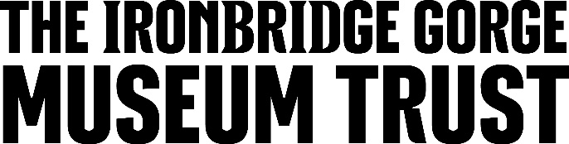

JOB DESCRIPTION

Job Title:
Visitor Engagement Demonstrator

Reports to:
Visitor Engagement Team Leaders

Hours/Contract:
Various hours/days/contracts available
School holidays, weekends and occasional evening availability required
Seasonal contracts to end September 2025

Salary:
NMW / NLW

Location:
Blists Hill Victorian Town, Legges Way, Madeley

Function:
To engage visitors with the stories, history, objects, buildings and activities of the Blists Hill Victorian Town through third person interpretation and demonstration.

To put our customers at the heart of everything we do.

Duties and Responsibilities:
- To deliver exemplary Customer Service to all visitors
- To be familiar with the history, manufacturing techniques and engagement activities of assigned exhibits and explain/demonstrate these clearly to all visitors’
- To wear costume and maintain a personal appearance in accordance with the Site Interpretation Policy
- To care for the objects in and around assigned exhibits, reporting items lost, stolen or damaged immediately to the Curatorial Team
- With support from the Curatorial Team maintain the authentic interior and exterior design of the exhibit in accordance with the Site Interpretation Policy
- Maintain a safe and clean environment in the exhibit and its immediate surroundings at all times
- Adhere to and comply with the Trusts Health & Safety Policy at all times
- Abide by all training and safe working practices for the exhibit, be responsible for staff and visitor safety by undertaking daily check lists and informing the Visitor Engagement Team Leaders of any issues which may require attention
- Where required handle a till, decimal and token coinage and complete all account paperwork
- Where required ensure exhibit is fully stocked, place orders and undertake stock-takes
- To undertake such other duties as may be deemed appropriate by the Visitor Engagement Manager or Deputy Visitor Engagement Manager.

Person Specification:
Essential
- Excellent communication skills
- Experience of a customer service focused operation
- Ability to work as a team
- Ability to work under pressure
- Good organisational and interpersonal skills
- Ability to use own initiative
- Flexible in approach to work.

Desirable
- Experience of heritage/cultural organisation.

Signed (postholder): …………………………… Printed: ……….………….. Dated: …………..….

Signed (manager): ……………………………… Printed: …………………….. Dated: …………..….

This job description is subject to periodic review.

