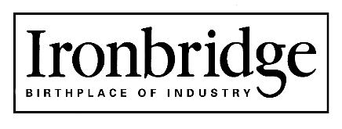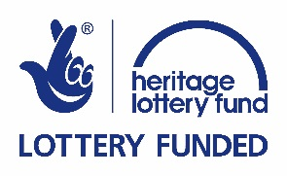

JOB DESCRIPTION

JOB TITLE: Fundraising Officer – Fund for the Future

REPORTS TO: Fundraising Manager

TERM: 12 month Fixed Term Contract – Full-time

LOCATION: Coalbrookdale Head Office, Coach Road, Telford

SALARY: Dependent on experience

FUNCTIONS: To manage all elements of the Heritage Lottery Fund (HLF) £1 million Endowment Scheme, which is the lead donation in the Trust’s ‘Fund for the Future’ appeal.

DUTIES INCLUDE:

- Work with the Fundraising Manager and Director of Museum Development to implement and manage a plan to raise £1 for £1 match funding to unlock the HLF Endowment fund
- Responsibility for day to day development of the fund
- Working with the Research Officer identify potential donors
- Development and management of cultivation events and campaigns in both Ironbridge and London
- Development of specific ‘Fund for the Future’ Legacy campaign linked to the Forge Society
- Creation of associated print and digital marketing materials
- Associated administration including accurate tracking of donations, acknowledgement of donations and thank you letters
- Progress reports for Board and Heritage Lottery Fund
- Evaluation of the scheme focussing on the success of the fundraising campaign and the improvements to the heritage assets

STAFF REPORTING DIRECTLY: N/A

BUDGETS HELD: N/A

This Job Description is subject to periodic review.

PERSON SPECIFICATION

Essential
- Relevant qualifications, e.g. A-Levels or equivalent
- Proven track record of fundraising within a complex charity or in a sales and marketing role
- Understanding of Endowment and Legacy appeals
- Proven success in face to face solicitation of donors and a record in closing gifts
- Experience and proven track record in running fundraising campaigns and appeals
- A broad understanding and appreciation of the work of museums and other cultural providers
- Excellent organisational, interpersonal and communication skills with the ability to converse effectively and convincingly with a wide range of people including prospective donors, supporters and senior staff
- The ability to develop and maintain productive working relationships with colleagues and external contacts with a broad community of interests
- Ability to work independently and as part of a team
- Excellent ITC skills, including Customer Relationship Management (CRM) systems
- Competent and confident user of social media
- Full driving licence & access to own vehicle and able to attend evening and weekend events when required.

Desirable
- Experience of event organisation
- Fundraising qualification

Signed (Postholder)……………………….. Printed ………………………. Dated ………………..

Signed ……………………………………….Printed ………………………. Dated ………………..
(Director of Museum Development)

Signed (Chief Executive)………………… Printed....................................... Dated ………………..

